Reference:
http://www.cs.gmu.edu/cne/workbenches/ring/ring.html

Election in Distributed Systems

Many distributed algorithms require one process to act as coordinator, initiator, sequencer, or to perform some other special role. In the centralized mutual exclusion algorithm, one process is elected as the coordinator. For instance, the process running on the machine with the highest network address might be selected. Whenever a process wants to enter a critical region, it sends a request message to the coordinator stating which critical region it wants to enter and asking for permission. If no other process is currently in that region, the coordinator sends back a reply granting permission.
It does not matter which process takes on this special responsibility of coordinator, but one of them has to do it. In general, election algorithms attempt to locate the process with the highest process number and designate it as coordinator. The algorithms differ in the way they specify the location. We assume that every process knows the process number of every other process. What the processes do not know is which ones are currently up and which ones are currently down. The goal of election algorithm is to ensure that when an election starts, it concludes with all processes agreeing on who the new coordinator is to be.
Distributed Election Using the Bully Algorithm
This workbench demonstrates how the Bully Election Algorithm elects a single coordinator in the presence of failures.
Distributed Election Using the Ring Election Algorithm
This workbench demonstrates how the Ring Election Algorithm elects a single coordinator in the presence of failures.

Bully Election Algorithm Workbench

The Bully Algorithm was devised by Garcia-Molina in 1982. When a process notices that the coordinator is no longer responding to requests, it initiates an election. Process P, holds an election as follows:
1) P sends an ELECTION message to all processes with higher numbers.
2) If no one responds, P wins the election and becomes coordinator.
3) If one of the higher-ups answers, it takes over. P's job is done.
At any moment, a process can get an ELECTION message from one of its lower-numbered colleagues. When such a message arrives, the receiver sends an OK message back to the sender to indicate that it is alive and will take over. The receiver then holds an election, unless it is already holding one. Eventually, all processes give up but one, and that one is the new coordinator. It announces its victory by sending all processes a message telling them that starting immediately it is the new coordinator.
If a process that was previously down comes back up, it holds an election. If it happens to be the highest-numbered process currently running, it will win the election and will take over the coordinator's job. Thus the biggest guy in town always wins, hence the name "Bully Algorithm".
The workbench displays four processes. There are two queues associated with each process: a queue of requests received from other processes and a queue of requests waiting for an acknowledgement from other processes. Processes are color-coded as follows: red stands for an alive non-coordinator process, purple indicates a coordinator, and gray represents a process that is down. Every non-coordinator process sends requests (circles) to the coordinator and waits for an acknowledgement before sending the next request. Acknowledgement messages are indicated by circles within rectangles. If the acknowledgement does not arrive in a given timeout, the process starts an election by sending ELECTION messages (bars).
The simulation can be controlled on a step-by-step basis by pushing the buttons that correspond to each process. These buttons can cause the individual processes to send requests, fail, or recover. The simulation can also be run in the animation mode in which processes operate concurrently and go up and down randomly. The speed of the animation can be controlled by the "Slow Ratio" slide at the top of the demonstration. Moving the slide to the right will slow down the animiation.

Ring Election Algorithm Workbench

This election algorithm is based on the use of a ring. We assume that the processes are physically or logically ordered, so that each process knows who its successor is. When any process notices that the coordinator is not functioning, it builds an ELECTION message containing its own process number and sends the message to its succesor. If the succesor is down, the sender skips over the successor and goes to the next number along the ring, or the one after that, until a running process is located. At each step, the sender adds its own process number to the list in the message.
Eventually, the message gets back to the process that started it all. That process recognizes this event when it receives an incoming message containing its own process number. At that point, the message type is changed to COORDINATOR and circulated once again, this time to inform everyone else who the coordinator is (designated by the list member with the highest number) and who the members of the new ring are. When this message has circulated once, it is removed and everyone goes back to work.
The workbench displays four processes. There are two queues associated with each process: a queue of requests received from other processes and a queue of requests waiting for an acknowledgement from other processes. Processes are color-coded as follows: red stands for an alive non-coordinator process, purple indicates a coordinator, and gray represents a process that is down. Every non-coordinator process sends requests (circles) to the coordinator and waits for an acknowledgement before sending the next request. Acknowledgement messages are indicated by circles within rectangles. If the acknowledgement does not arrive in a given timeout, the process starts an election by sending ELECTION messages (bars).
The simulation can be controlled on a step-by-step basis by pushing the buttons that correspond to each process. These buttons can cause the individual processes to send requests, fail, or recover. The simulation can also be run in the animation mode in which processes operate concurrently and go up and down randomly. The speed of the animation can be controlled by the "Slow Ratio" slide at the top of the demonstration. Moving the slide to the right will slow down the animiation.
Demonstration of Bully algorithm:
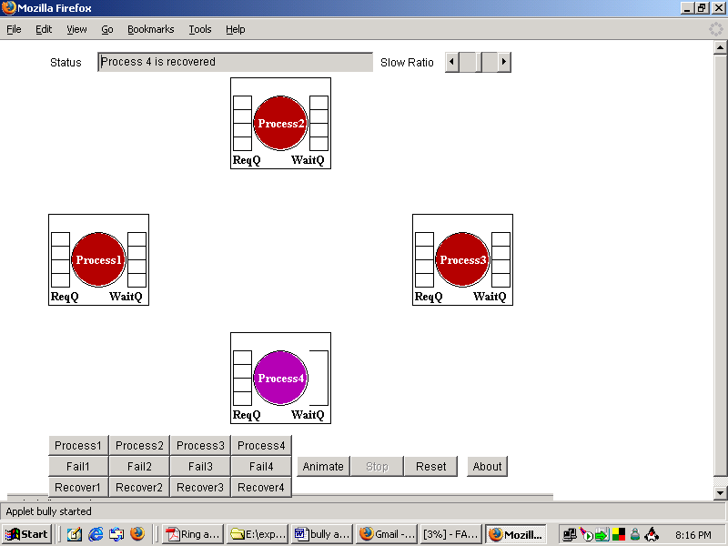
Demonstration of Ring algorithm:
Similar for bully algorithm.

